Villa 105, Road 2208, Damistan1022, Kingdom of Bahrain

Mohammed Hussain Mohammed Kadhem

Mobile: +973 37173355 - 39820824

Email;kmmk1911@gmail.com

**Personal Details:**

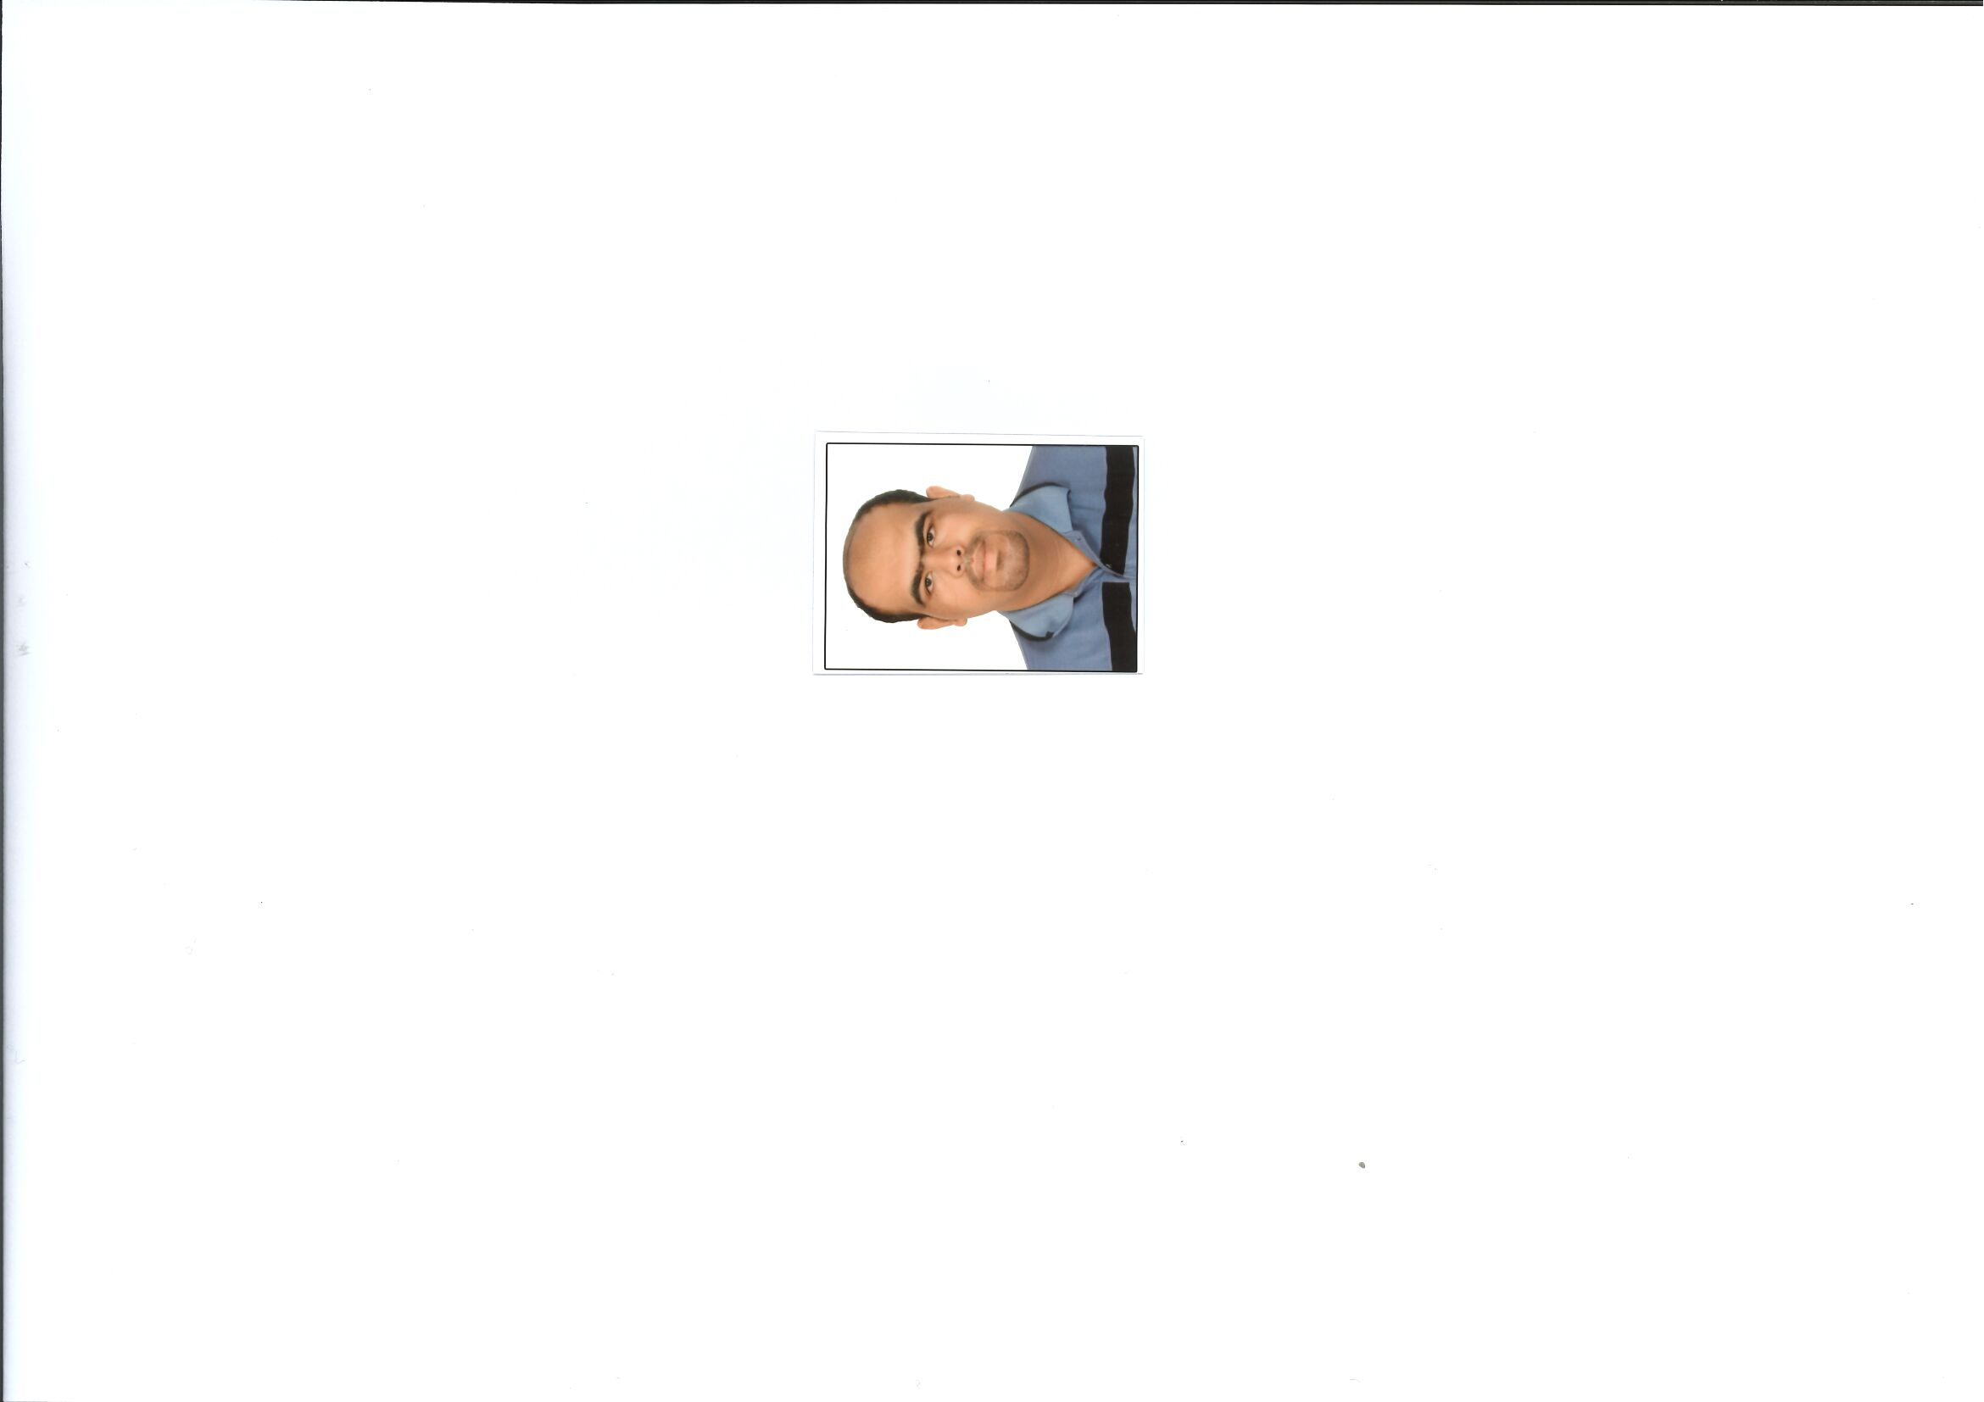 Nationality: Bahraini

Date of Birth: 05/06/1993

Place of Birth: Jidhafs

Gender: Male

Marital Status: Single

CPR Number: 930607597

**Educational Qualification:**

2017 University of Bahrain / B.A. in History (Bahrain and the Arabian Gulf) - Sociology

2011 Sheikh Issa Bin Ali Secondary School Certificate

**Additional Skills:**

* Interpersonal: Driving License car, Hard work
* Languages: Arabic reading, spelling & writing
* Computer: MS Office Windows, Excel, Power point, Speed Typing, Using Internet

**Hobbies:**

* Reading
* Play Football
* Play Volleyball

**Reference:**

Available upon request